DATAWARE HOUSING AND DATA MINING – UNIT 2 - LAB PROGRAMS
M KAVYA 192472370
PROGRAM 1:
# Covariance and Correlation

A <- c(18,2,20)
B <- c(22,28,10)
C <- c(20,40,40)

data <- data.frame(A,B,C)

# Covariance between B and C
print(cov(B,C))

# Covariance Matrix
print(cov(data))

# Correlation between B and C
print(cor(B,C))

# Correlation Matrix
print(cor(data))

# Data Partitioning

values <- c(18,18,18,20,20,20,20,20,20,20,
21,21,21,21,25,25,25,25,25,
28,28,30,30,30)

# Equal frequency partition (bin size = 3)

bins <- split(values, ceiling(seq_along(values)/3))

print(bins)

# Bin Mean Smoothing

mean_smoothing <- sapply(bins,mean)

print(mean_smoothing)

# Bin Boundary Smoothing

boundary <- lapply(bins,function(x){
min_val <- min(x)
max_val <- max(x)

sapply(x,function(y){
if(abs(y-min_val)<abs(y-max_val))
min_val
else
max_val
})
})

print(boundary)

# Histogram

hist(values,
main="Histogram",
xlab="Values",
col="skyblue")
OUTPUT:
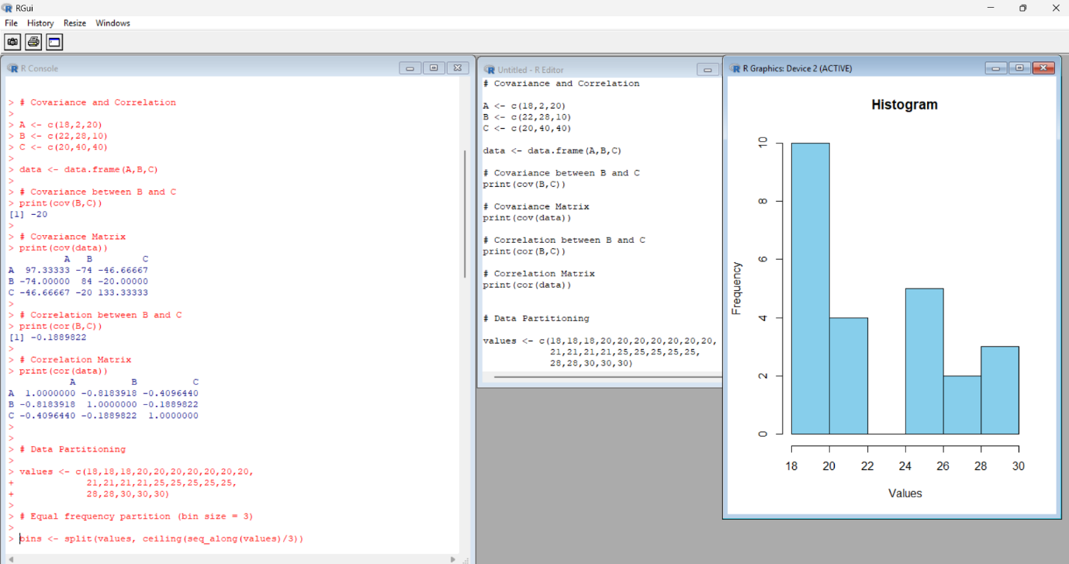

PROGRAM 2:
price <- c(1,1,5,5,5,5,5,8,8,
10,10,10,10,12,14,14,
14,15,15,15,15,15,15,
18,18,18,18,18)

hist(price,
breaks=10,
main="Electronics Price Distribution",
xlab="Price",
col="orange")
OUTPUT:
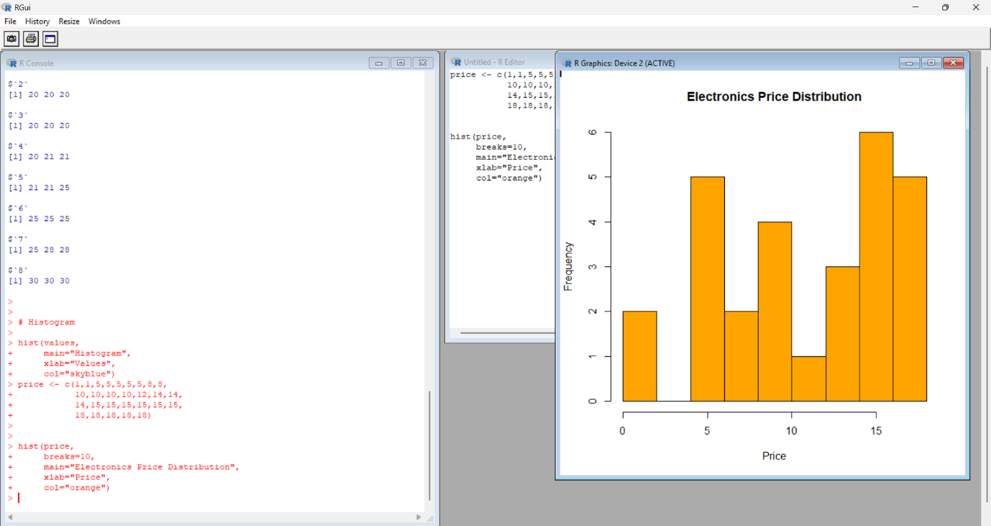

PROGRAM 3:
ClassA <- c(76,35,47,64,95,66,89,36,84)

ClassB <- c(51,56,84,60,59,70,63,66,50)

# Mean
cat("Class A Mean:",mean(ClassA),"\n")
cat("Class B Mean:",mean(ClassB),"\n")

# Median
cat("Class A Median:",median(ClassA),"\n")
cat("Class B Median:",median(ClassB),"\n")

# Range
cat("Class A Range:",diff(range(ClassA)),"\n")
cat("Class B Range:",diff(range(ClassB)),"\n")

# Boxplot

boxplot(ClassA,ClassB,
names=c("Class A","Class B"),
main="Class Comparison",
col=c("blue","green"))
OUTPUT:
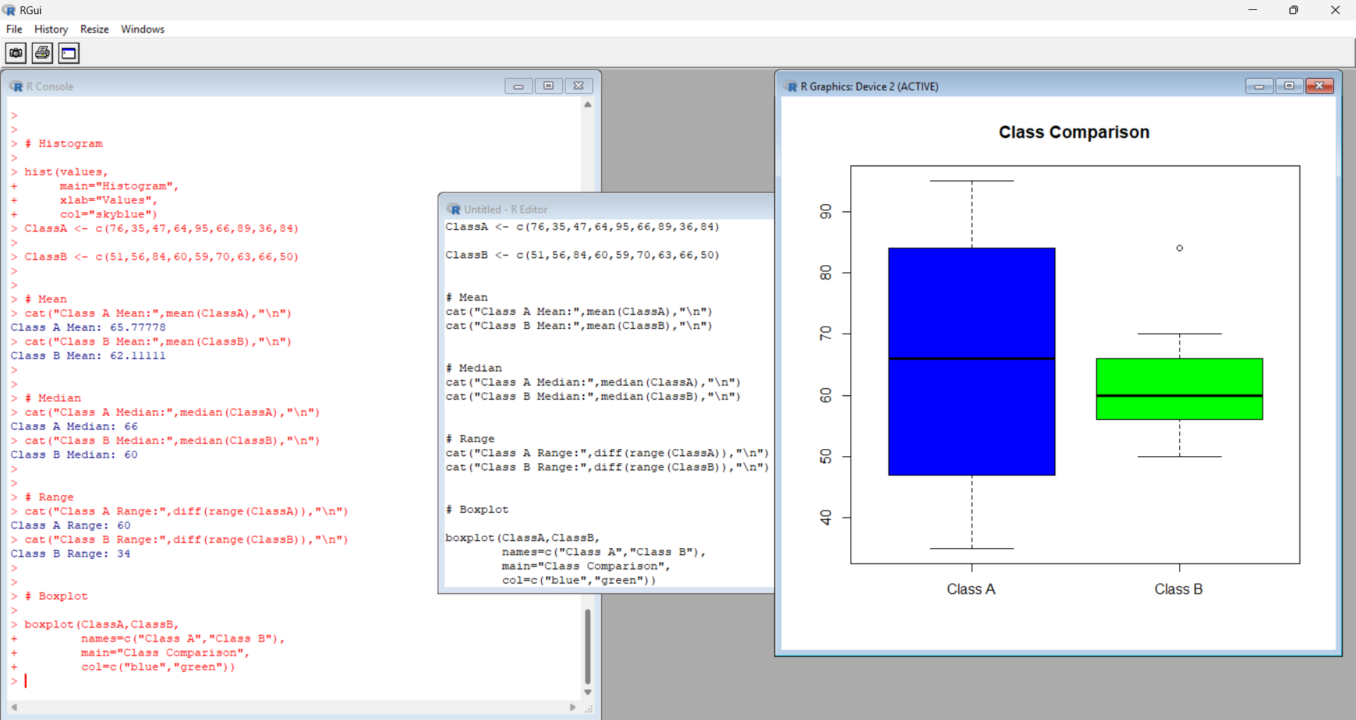
PROGRAM 4:
data <- c(200,300,400,600,1000)

# Min-Max Normalization

minmax <- (data-min(data))/(max(data)-min(data))

cat("Min-Max Normalization:\n")
print(minmax)

# Z-score Normalization

zscore <- (data-mean(data))/sd(data)

cat("Z-score Normalization:\n")
print(zscore)

OUTPUT: 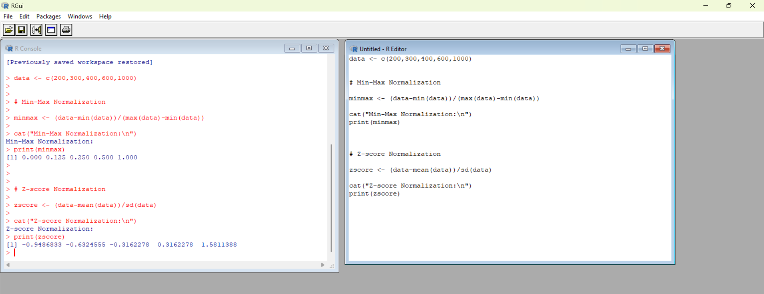
PROGRAM 5:
data(AirPassengers)

hist(AirPassengers,
breaks=seq(100,700,150),
main="AirPassengers Histogram",
xlab="Number of Passengers",
col="purple")
OUTPUT:
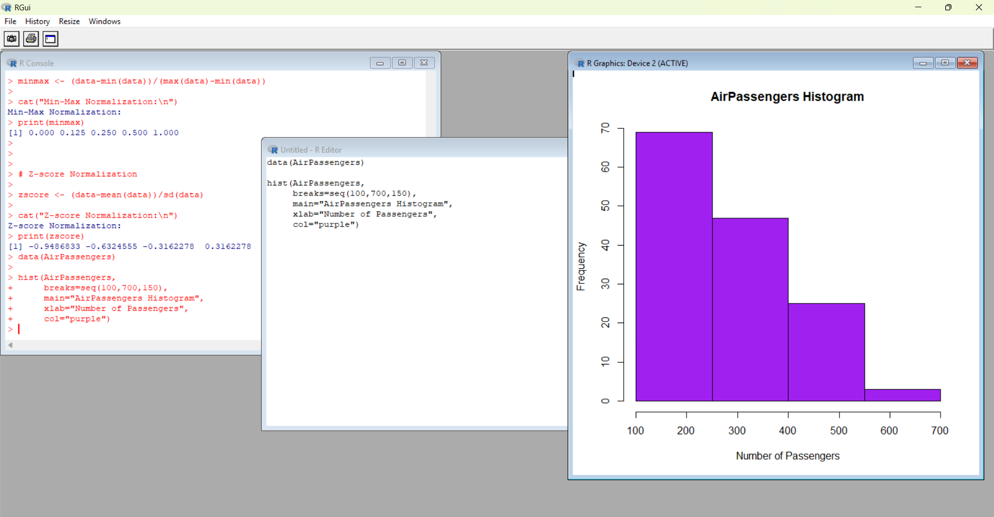

PROGRAM 6:
data(mtcars)

plot(mtcars$mpg,
type="o",
col="blue",
main="MPG and QSEC",
xlab="Index",
ylab="Values")

lines(mtcars$qsec,
type="o",
col="red")

legend("topright",
legend=c("MPG","QSEC"),
col=c("blue","red"),
lty=1)

OUTPUT:

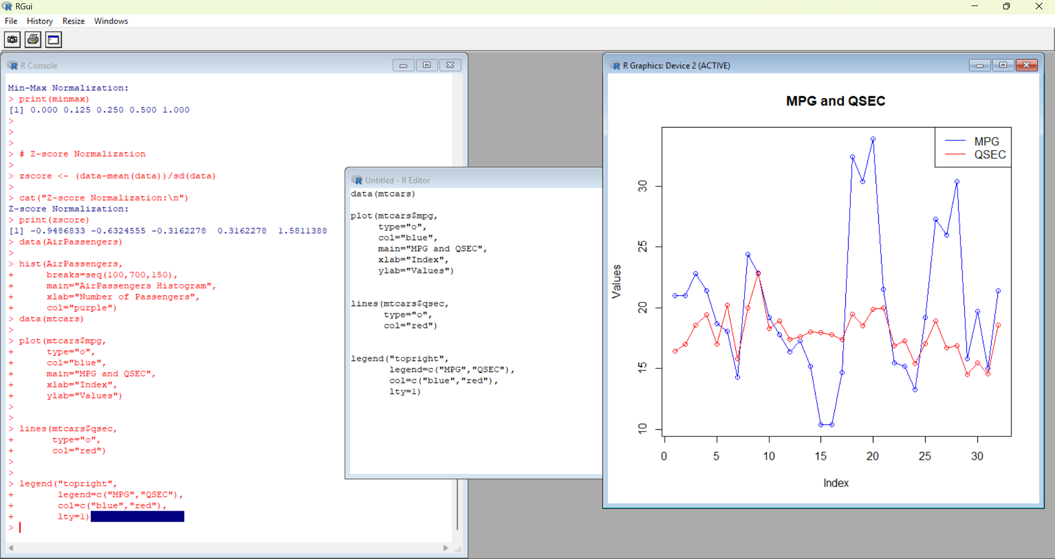

PROGRAM 7:
# ------------------------------------------------------------
# Question 7: Mortality vs Hardness Analysis (DWDM Lab)
# ------------------------------------------------------------

# Step 1: Create sample dataset (since 'water' is no longer in MASS)
water <- data.frame(
hardness = c(60, 70, 80, 90, 100, 110, 120, 130, 140, 150),
mortality = c(160, 150, 145, 140, 135, 130, 125, 120, 118, 115)
)

# Step 2: Inspect dataset
head(water)
str(water)

# Step 3: Scatter Plot (Pattern Discovery)
plot(water$hardness, water$mortality,
main = "Mortality vs Hardness",
xlab = "Hardness",
ylab = "Mortality",
col = "blue", pch = 19)

# Step 4: Fit Linear Regression Model
model <- lm(mortality ~ hardness, data = water)

# Add regression line to the plot
abline(model, col = "red", lwd = 2)

# Step 5: Model Evaluation
summary(model)

# Step 6: Prediction for hardness = 88
new_data <- data.frame(hardness = 88)
predicted_mortality <- predict(model, new_data)

# Display the result
cat("Predicted Mortality for Hardness = 88:", predicted_mortality, "\n")

OUTPUT:
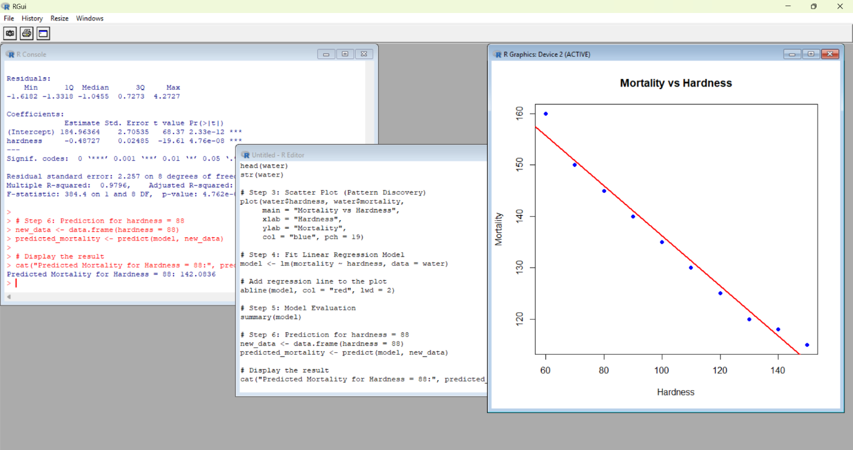

PROGRAM 8:
data(mtcars)

boxplot(mpg~cyl,
data=mtcars,
main="MPG vs Cylinders",
xlab="Cylinders",
ylab="Miles Per Gallon",
col="cyan")

OUTPUT:
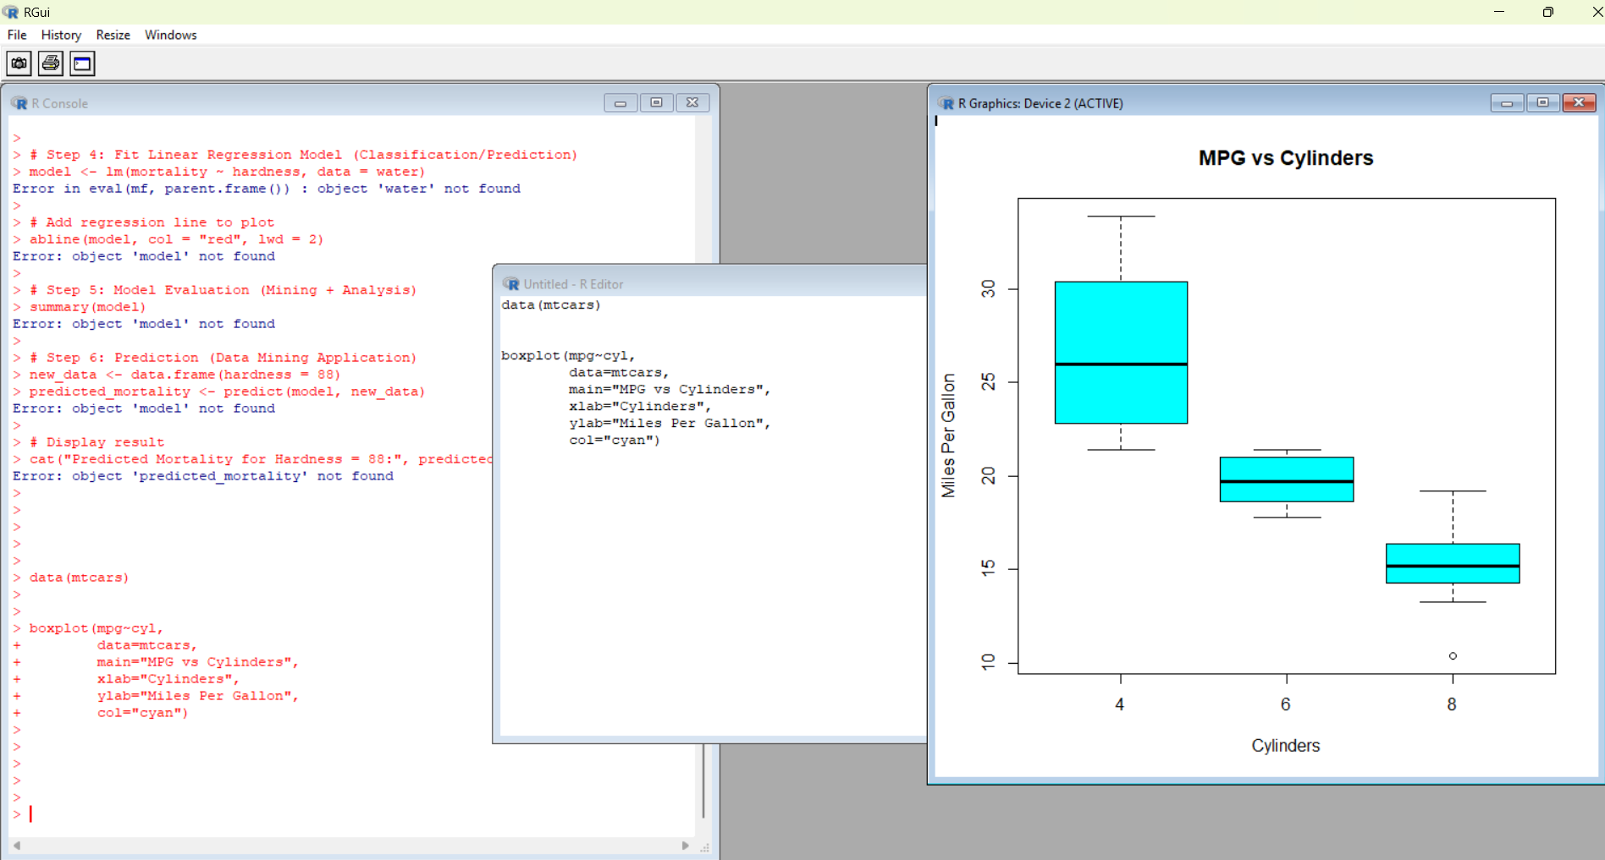

PROGRAM 9:
scores <- c(20,25,30,35,40,45,50,55,90)

boxplot(scores,
main="Tennis Player Scores",
ylab="Points",
col="yellow")

# Detect Outliers

outliers <- boxplot.stats(scores)$out

cat("Outliers are:")
print(outliers)

OUTPUT:
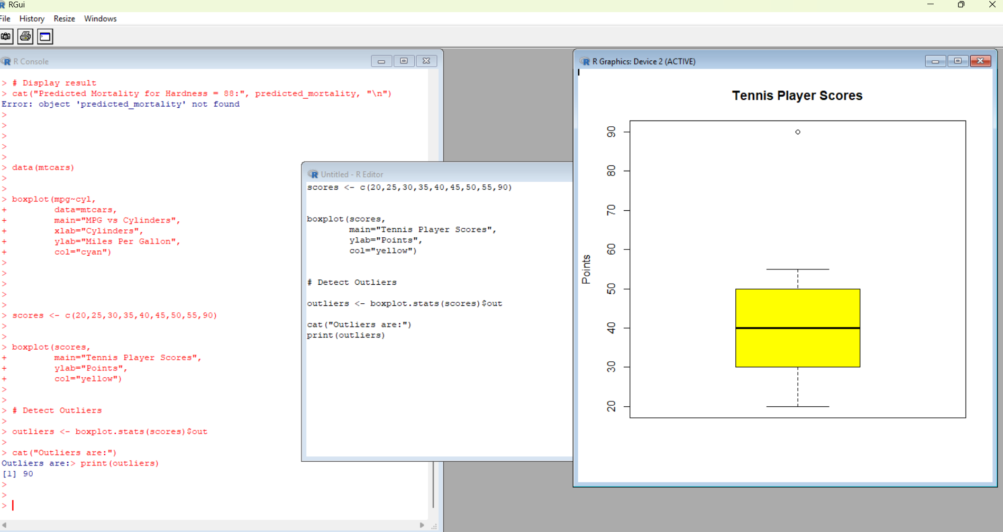
PROGRAM 10:
# Diabetes Dataset Analysis in R

# Step 1: Load dataset
diabetes <- read.csv("diabetes.csv")

# Step 2: Inspect dataset
head(diabetes)
str(diabetes)

# Step 3: Scatter Plot
plot(diabetes$Age,
diabetes$BloodPressure,
main = "Blood Pressure vs Age",
xlab = "Age",
ylab = "Blood Pressure",
col = "blue", pch = 19)

# Step 4: Bar Chart
avg_bp <- aggregate(BloodPressure ~ Age,
data = diabetes,
mean)

barplot(avg_bp$BloodPressure,
names.arg = avg_bp$Age,
main = "Age vs Average Blood Pressure",
xlab = "Age",
ylab = "Average Blood Pressure",
col = "green")
OUTPUT:
